**Pennsylvania Historic Tax Credit Advocacy Resources**

General Talking Points:

* The Pennsylvania Historic Preservation Tax Credit is a 25% credit applied to qualified rehabilitation costs up to $500,000 for income-producing historic buildings.
  + In the first five years of the program, the program awarded $15 million in credits, which supported projects totaling $700 million in investment.
  + A $1 million investment in a historic rehabilitation project generates 6.4 direct jobs and 5.6 indirect jobs in Pennsylvania, more than any other industry, including gas.
* Last July, our coalition successfully raised the program’s aggregate cap to $20 million, which will go into effect in July 2025 and will quadruple the available funding. The program was initially funded at $3 million annually in 2012 and increased to $5 million in 2019.
* Three additional provisions that would strengthen the program were not included in the final budget, despite having strong bipartisan support in the House and Senate. We are introducing legislation that will include these three remaining provisions
* Most importantly, the legislation would raise the per-project cap to $1.5 million. Currently, each rehabilitation project is capped at receiving $500,000 in PA historic tax credits.
  + When thinking of transformative historic rehabilitation projects, this is a nominal sum in comparison to their full construction costs.
  + Of the 21 other state historic preservation programs that have a per-project cap, the average is $4 million. Only Arkansas, New Mexico, and Vermont’s state historic preservation programs have per-project caps lower than PA’s of $500,000
* The legislation would also resolve a technical issue, ensuring that syndicated partnerships with a non-profit are eligible for the program. The Department of Revenue has sometimes flagged these applications as a “disregarded entity of a nonprofit group” and rejected them.
  + Many affordable and senior housing and social service projects have been funded this way throughout the Commonwealth.
  + No other state has made this determination, and the language in this bill mirrors that of several states that allow nonprofits to be part of a development group for a historic preservation project.
* The legislation would also change the application fee structure, which supports the Department of Community and Economic Development and the Pennsylvania Historical and Museum Commission’s review of the project applications.
  + Currently, there is a flat fee of $100 per application, which is split 50/50 by DCED and PHMC. This does not support the efficient review of applications.
* This program works as a companion to the federal Historic Tax Credit, which Pennsylvania has always been a strong user of.
  + Since 1977, the federal program has incentivized the rehabilitation of over 3,000 buildings in PA with investments in excess of $7 billion. Between 2002 and 2022, the economic impact of 1,040 approved projects in PA generated $4.1 billion in development costs, created 106,703 jobs, generated $4.2 billion in income, and $1.6 billion in local, state, and federal taxes.
  + *Reference* [[*PA*](https://forum.savingplaces.org/viewdocument/historic-tax-credit) *Federal HTC Project Map*](https://cdn.savingplaces.org/2023/06/09/16/37/15/663/PA_HTC_FY01-22.pdf) and Annual Report
* *Describe how an HTC project has benefitted your community.*

**Ask**: Please support the forthcoming legislation that would strengthen PA’s historic tax credit program

*Direct staffers with questions to Mindy Crawford, (*[*mcrawford@preservationpa.org*](mailto:mcrawford@preservationpa.org)*), or Hanna Stark, (*[*hstark@preservationalliance.com*](mailto:hstark@preservationalliance.com)*)*

Meeting with your State Legislator:

*Scheduling*

Find your state legislators: <https://www.legis.state.pa.us/cfdocs/legis/home/findyourlegislator/>

On their profile, there is an email icon, highlighted below:

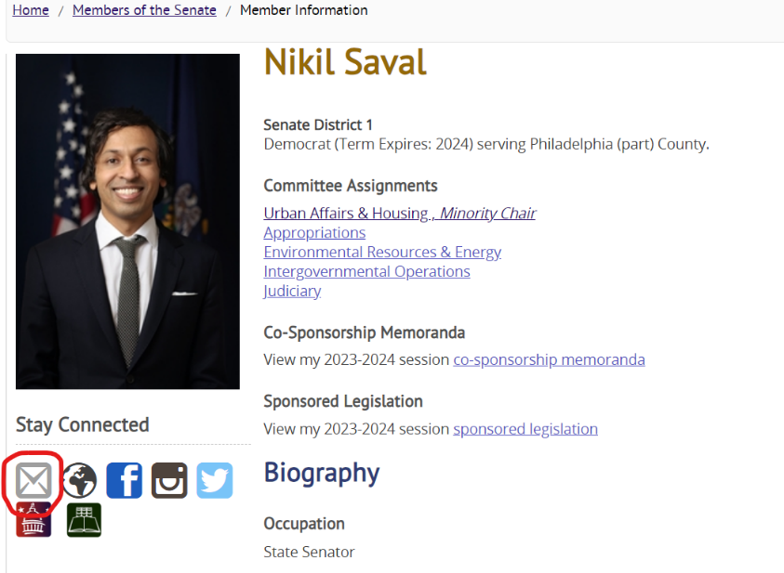

Below is boilerplate language to ask your legislator to meet to discuss the tax credit program. We will circulate specific asks as the bill moves through the legislative process. We suggest attaching the [[issue brief](https://preservationalliance.com/wp-content/uploads/2023/09/PATaxCreditCase.pdf)](https://preservationalliance.com/wp-content/uploads/2023/09/Issue-Brief-6-17.pdf) so staff can familiarize themselves with the program.

Subject: Strengthen the PA Historic Preservation Tax Credit Program

“Dear [NAME]

I’m writing to you on behalf of my organization [XYZ] as well as other historic preservationists from [AREA].

I would like to discuss an important preservation tool, the PA Historic Preservation Tax Credit, with your office. Senators Farry, Argall and Saval are sponsoring legislation that will strengthen this program. Established in 2012, the program has encouraged private sector investment in the rehabilitation and re-use of many irreplaceable historic buildings across the Commonwealth.

Could you please let me know your availability to meet? Thank you so much for considering this request. If there is someone on staff with whom I should speak about this policy area, please let me know.

Sincerely, [YOUR INFO]”

*During the Meeting*

We recommend getting to the point of the meeting quickly, being succinct, and keeping the meeting brief. Be specific about what you want the member to do for you. We encourage using specific examples from your member’s district to support your point. Always look for opportunities to be of service to the member. For example, offer to send follow-up information regarding issues that came up during the meeting, or, if there is interest, offer to help organize an in-person visit when the member is in the district.

*Follow-Up*

After your meeting, please take a moment to send “thank you” e-mails. Staff will appreciate having your contact information and a reminder about the specific request you made of them during the meeting.

Additional Resources:

[Issue Brief](https://preservationalliance.com/wp-content/uploads/2023/09/PATaxCreditCase.pdf), April 2025

[PA Historic Preservation Tax Credit: An Evaluation of Program Performance, Independence Fiscal Office](http://www.ifo.state.pa.us/releases/530/Historic-Preservation-Tax-Credit/), 2019

[Missing Key: A Study of the Impact and Potential of the Pennsylvania State Historic Tax Credit](https://www.preservationpa.org/wp-content/uploads/2020/03/PA-HPTC-Economic-Study_PresPA_web.pdf), Preservation Pennsylvania, 2019

[State Historic Tax Credit Resource Guide](https://cdn.savingplaces.org/2023/03/31/15/02/36/841/NTHP_HTC_2023_StateGuide.pdf), National Trust for Historic Preservation, January 2023

[Pennsylvania Federal Historic Tax Credit Investment FY01 - FY22](https://cdn.savingplaces.org/2023/06/09/16/37/15/663/PA_HTC_FY01-22.pdf), National Trust for Historic Preservation, 2023

**PA Historic Tax Credit Coalition Members** (as of 4/15/25)

